The Roscommon SPCA 100km Walk

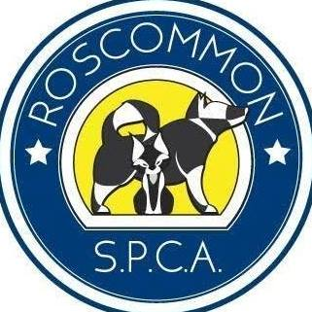

Week Date

Distance

Time

Walk Type Route, Description, Comments

1
2
3
4
5

