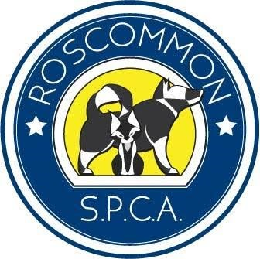

Roscommon Society for the Prevention of Cruelty to Animals
Charity No: 20072735 - CHY: 18790

Name :
Address:
Telephone Number: Email:
There are many way to help us in our work with the animals in the County. If you have some ideas, please let us know.

Fundraising |  |  | Transporting Animals |  |  | Street Collections |  |  | Bag Packing
Community Market |  |  | Pop Up Shops |  |  | Dealing with Feral Cats |  |  | Coffee Mornings
Please note that membership of Roscommon SPCA does NOT allow you to represent Roscommon SPCA in any official capacity. Membership is at the discretion of Roscommon SPCA Committee. I apply for membership of Roscommon SPCA and agree to abide by the rules.

MEMBERSHIP FEES
SINGLE: €10.00 | STUDENT: €5.00 |  |  | FAMILY: €15.00 |  |  | RETIRED/UNEMPLOYED: €5.00
We would prefer to contact you by email or text. We are trying to save money on paperwork and postage so all of our income goes directly to animal welfare. Please let us know how we can contact you:
EMAIL PHONE CALL TEXT LETTER

DATA PROTECTION STATEMENT - Collection and use of personal information
Signed: | Membership Fee: | Date:
Roscommon SPCA does not collect any personal data about you apart from information which you volunteer on here or (for example by filling out an online application form). Any information which you provide in this way is not made available to any third parties and is used by Roscommon SPCA only in line with the purpose for which you provided it. After a period of 2 years without contact, Roscommon SPCA will automatically delete all of your personal information from its database.

- If you would be interested in joining our Committee, please tick the box: YES NO

